APPARATUS WORK ORDER
MAG TEAMS – Division A

Club:
Level:

Due Friday 13th September 2019
Note: This order will be used for both rounds of competition.

Athlete Number | NAME |  | 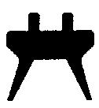 | 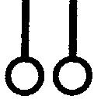 |  | 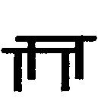

Team sheets for MAG & WAG are due by no later than 12:00pm, Friday 13th September 2019. If a club fails to submit their team sheets buy this time Gymnastics Australia will allocate a random draw for competition 1 & 2. No changes to team sheets will be accepted after this due date. Clubs will not be able to change teams 24 hours before the competition. In the case of a medical withdrawal, the replacement athlete with take the place of the injured athlete on each apparatus.

